**Zip App Orange Team**

**User Manual**

Authors:

Trevor Aupperle, Camden Davis, Benjamin Fisk, Mohab Yousef

COMP 4710 Senior Design Team #5

Department of Computer Science and Software Engineering

Samuel Ginn College of Engineering, Auburn University

April 26, 2024

# Table of Contents

**Table of Contents 1**

**1 Overview 2**

2 Admin 2

2.1 View Users 3

Figure 1 - Users Screen 3

2.2 Delete User 3

Figure 2 - Delete User Account Dialogue 4

2.3 Disable User Account 4

Figure 3 Disable User Account Dialogue 4

2.4 Reset User Password 4

Figure 4 - Reset Password Dialogue 4

2.5 Provide Refund 5

Figure 5 - Provide Refund Dialogue 5

**3 Generic 5**

3.1 Create Account 5

Figure 6 - Create an account. 6

3.2 Sign In 6

Figure 7 - Sign In 7

3.3 Reset Password 7

3.4 Edit Account Information 7

Figure 8 - How to Edit Account Information 8

3.5 Log Out 8

Figure 9 - How to Log out 9

3.6 Accept the Terms and Conditions 9

3.7 Accept the Privacy Policy 9

3.9 Accept Rules and Safety 9

3.10 Driver with Zip 9

Figure 10- How to become a driver. 10

**4 Rider 10**

4.1 Default Tip 10

Figure 11 - Add Tip 11

4.2 Request Ride 11

Figure 12 - Search for destination 12

4.3 Add Payment Method 12

Figure 13 - Add Payment Method 13

4.4 Delete Payment Method 13

4.5 View Previous Trips 13

Figure 14 - Previous Trips 14

4.6 Request Refund 14

4.7 Add Promo 14

Figure 15 - Add Promo Code 15

4.8 Rate and Tip Driver 15

Figure 16 - Rate & Tip Driver 16

**5 Driver 16**

5.1 Open Driver Portal 16

Figure 17 - Login as a Driver 17

5.2 Start Driving 17

Figure 18 - Start Driving 18

5.3 Stop Driving 18

Figure 19 - Stop Driving 19

5.4 Accept a Ride 19

Figure 20 - Accept a Ride 20

5.5 Finish A Ride 20

Figure 21 - End Ride 21

**6 Admin Portal 21**

6.1 Create a Promotion 21

Figure 22 - Add Promotion 22

6.2 Important Stats 22

Figure 23 - Important Stats 22

6.3 App Configuration 22

Figure 24 - App Configuration 23

6.4 User Accounts List 23

Figure 25 - User Accounts List 23

# 

# 1 Overview

The Zip application facilitates on-demand transportation services via golf carts to consumers, particularly in situations where venues are crowded and not easily accessible by car. The app includes separate portals for both riders and drivers. Riders can easily order transportation, specify their pickup location, make payments, and travel to their desired drop-off point. Meanwhile, drivers are connected with riders and receive information on their pickup location. Upon pickup, drivers receive GPS directions to the rider's destination and payment is processed to their checking account after the ride is completed. Riders are prompted to provide feedback upon completion of the ride.

# 2 Admin

## 2.1 View Users

To access the authenticated users list, please log in to the [Firebase Console here](https://console.firebase.google.com/u/0/project/zipgameday-6ef28/authentication/users). If you do not have authorization, please contact russell.anderson@zipgameday.com for access. Once logged in, click on the authentication icon located in the left navigation bar. This will display a list of authenticated users, including information such as their sign-up methods, last sign-in date, and account creation date.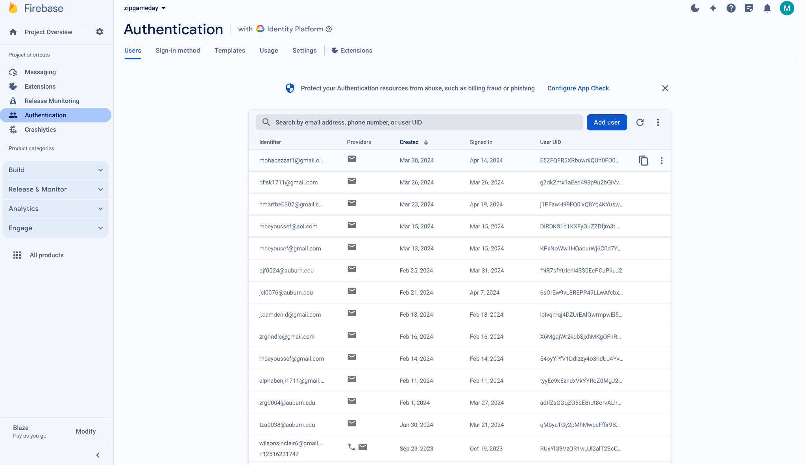

### Figure 1 - Users Screen

## 2.2 Delete User

To remove a user’s account, access [the Firebase Console](https://console.firebase.google.com/u/0/project/zipgameday-6ef28/authentication/users). Navigate to the authentication icon in the left navigation bar, and then hover over the right side of the user's UID. Three dots will appear, click on them and a list will appear. Finally, select the option to delete the user’s account.

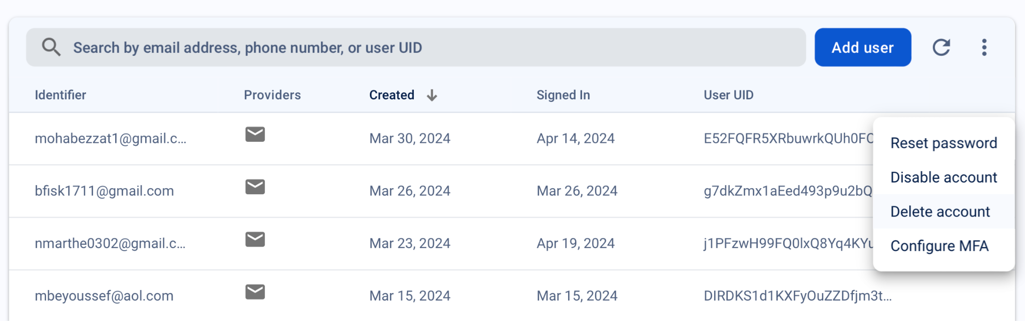

### Figure 2 - Delete User Account Dialogue

## 2.3 Disable User Account

To deactivate a user's account, access [the Firebase Console](https://console.firebase.google.com/u/0/project/zipgameday-6ef28/authentication/users). Navigate to the authentication icon using the left navigation bar. Hover over the right side of a user's UID, and three dots will appear. Click on the three dots, and a list will appear. From there, choose the option to disable the user's account.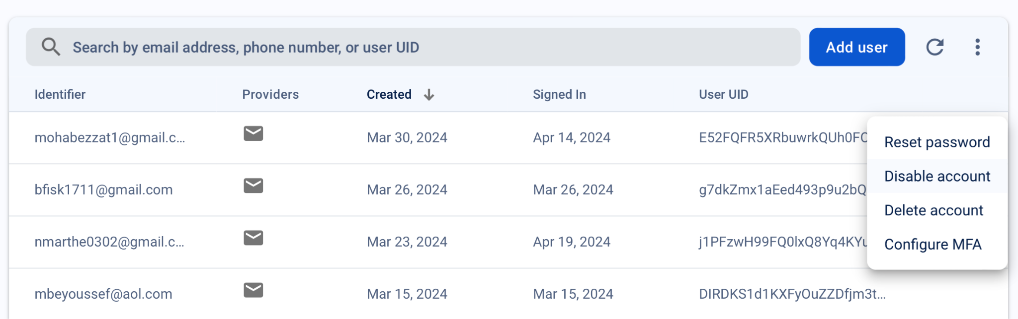

### Figure 3 Disable User Account Dialogue

## 2.4 Reset User Password

To reset a user's password, access [the Firebase console](https://console.firebase.google.com/u/0/project/zipgameday-6ef28/authentication/users). Navigate to the authentication icon via the left navigation bar. Locate the UID of the user in question and hover over its right side to reveal three dots. Click on the three dots to reveal a list of options, including the ability to reset the user's password. Following this action, an email containing instructions on how to reset their password will be sent to the user.

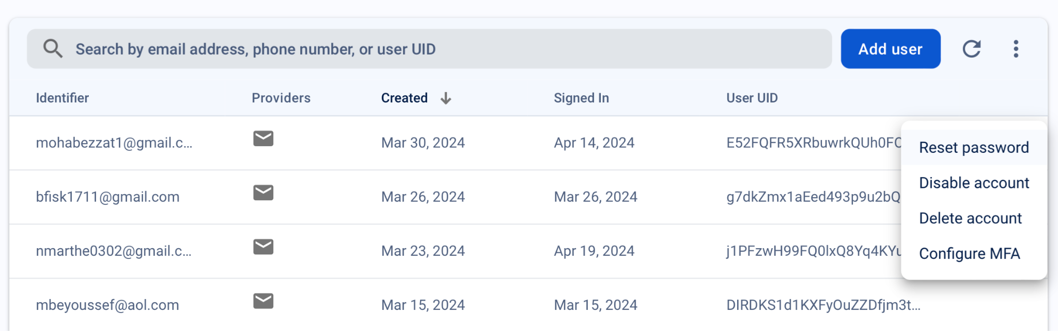

### Figure 4 - Reset Password Dialogue

## 2.5 Provide Refund

To process a refund, please access either the [Stripe Dashboard](https://dashboard.stripe.com/payments) (for live payments) or [the test payments section](https://dashboard.stripe.com/test/payments) (for test payments). Customers may request a refund for any reason, and administrators may process refunds using the Stripe Console.

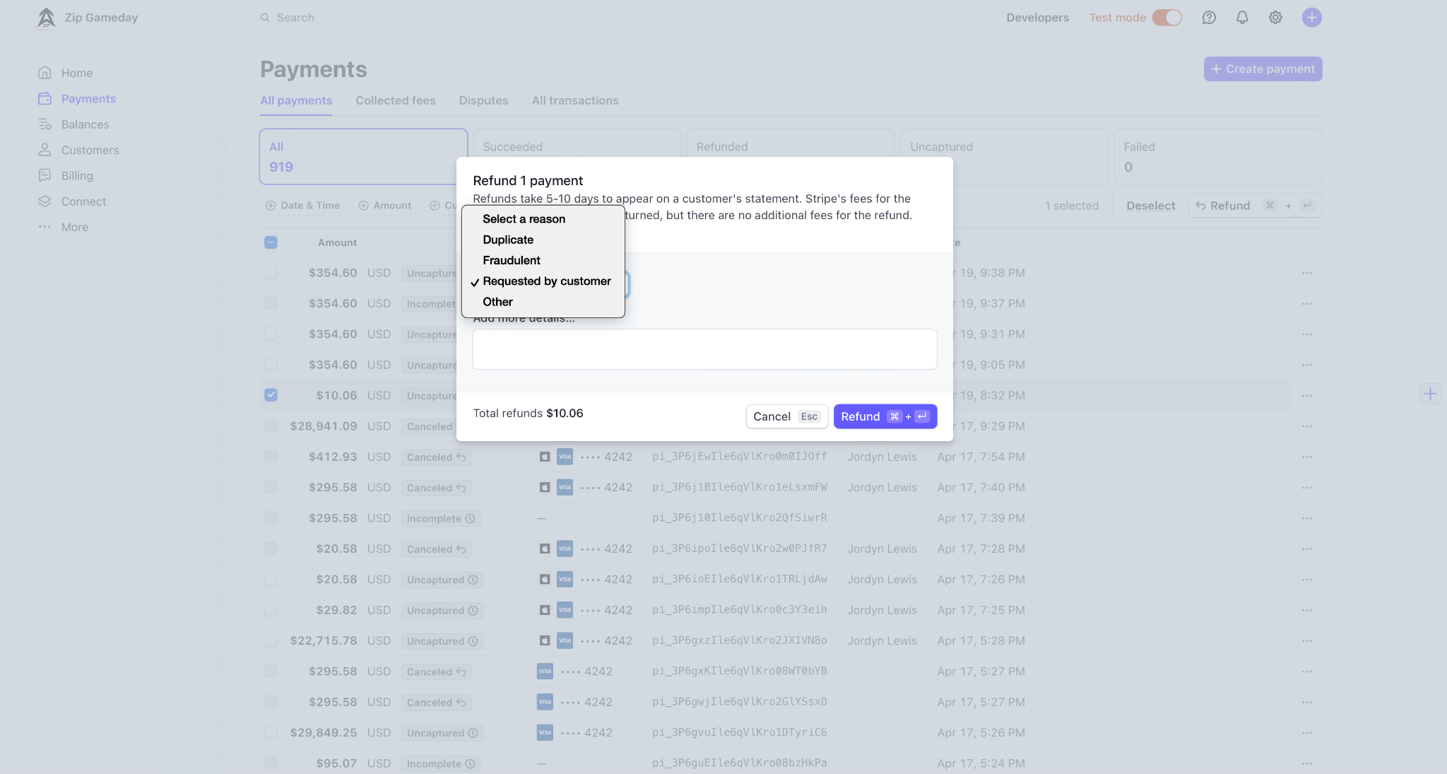

### Figure 5 - Provide Refund Dialogue

# 3 Generic

## 3.1 Create Account

Upon opening the application, users should click the ‘Join Us’ button to create their account. They should then follow the on-screen instructions to complete the account creation process.

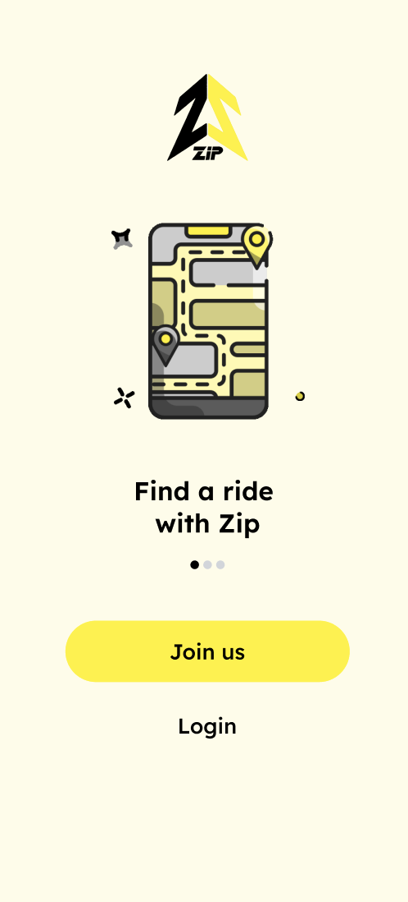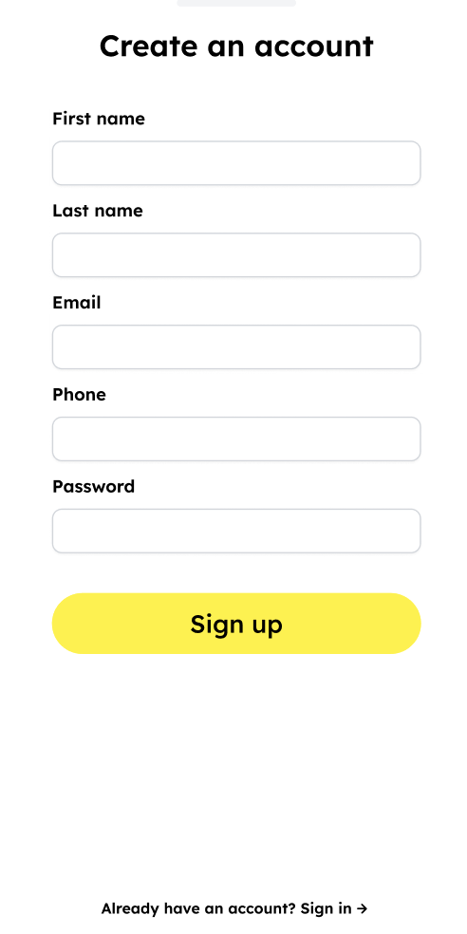

### Figure 6 - Create an account.

## 3.2 Sign In

Users can sign into their account using the Login button. Please follow the on-screen instructions to proceed with the login process.

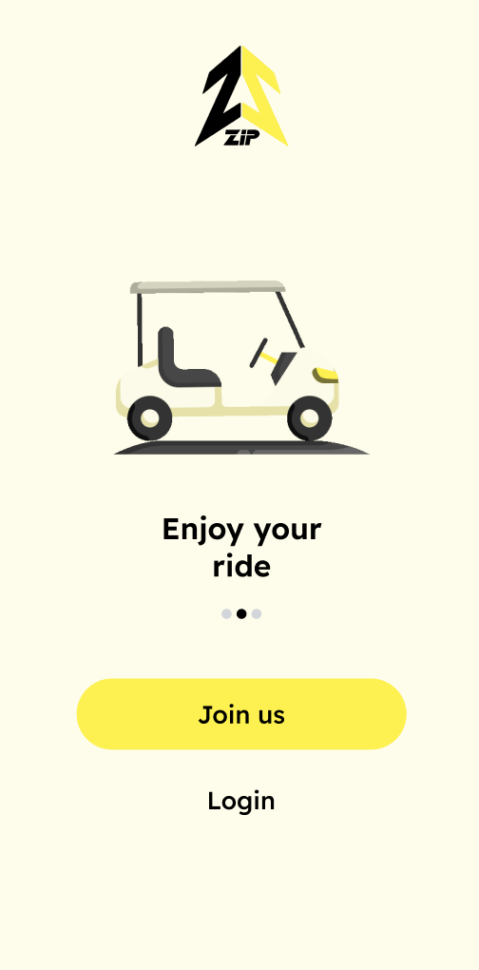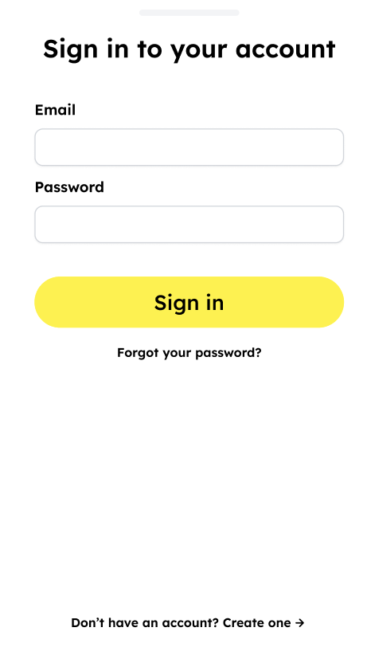

### Figure 7 - Sign In

## 3.3 Reset Password

To reset your password, select 'Log In' on the main screen and then choose 'Forgot Password?' You will be prompted to enter the email address associated with your account. A reset link will be sent to that email address. Follow the instructions provided in the email to reset your password.

## 3.4 Edit Account Information

To edit your profile, navigate to the account screen and select ‘Edit account details ’. This will allow you to modify your personal information, such as your name, email address, and phone number.

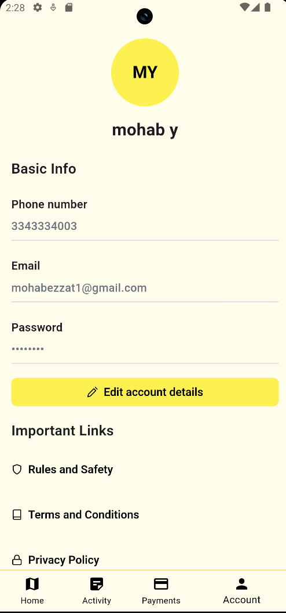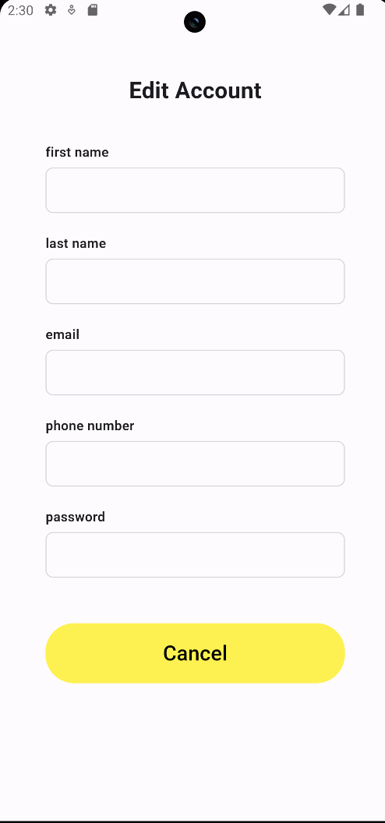

### Figure 8 - How to Edit Account Information

## 3.5 Log Out

To log out, navigate to the account screen and select ‘Logout’ at the bottom of the page.

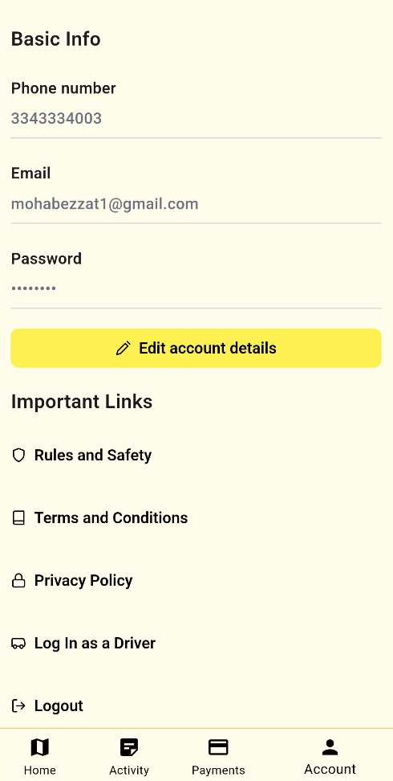

### Figure 9 - How to Log out

## 3.6 Accept the Terms and Conditions

To accept the terms and conditions, navigate to the account screen and select ‘Terms and Conditions’ near the bottom of the page.

## 3.7 Accept the Privacy Policy

To accept the privacy policy, navigate to the account screen and select ‘Privacy Policy’ near the bottom of the page.

## 3.9 Accept Rules and Safety

To accept the rules and safety regulations, navigate to the account screen and select ‘Rules and Safety’ near the bottom of the page.

## 3.10 Driver with Zip

To become a Zip Driver, navigate to the account screen and select ‘Become a Driver’ near the bottom of the page. Then follow the directions to enter your information and become a driver

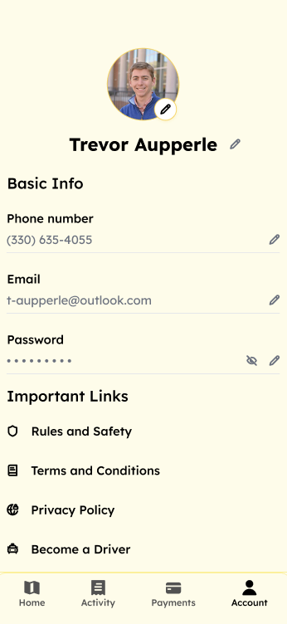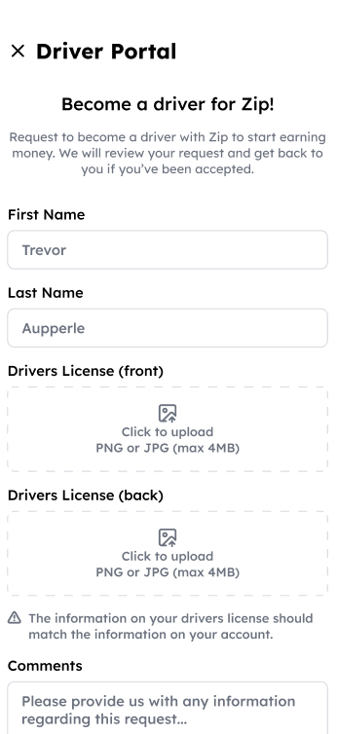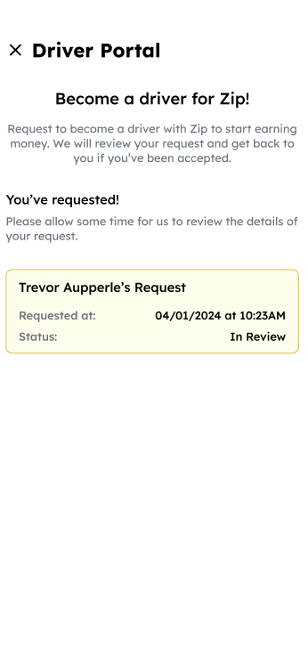

### Figure 10- How to become a driver.

# 4 Rider

## 4.1 Default Tip

To change your default tip percentage, navigate to the payments screen and select the default tip bar. Then select your desired percentage from the shown options or add a custom percentage.

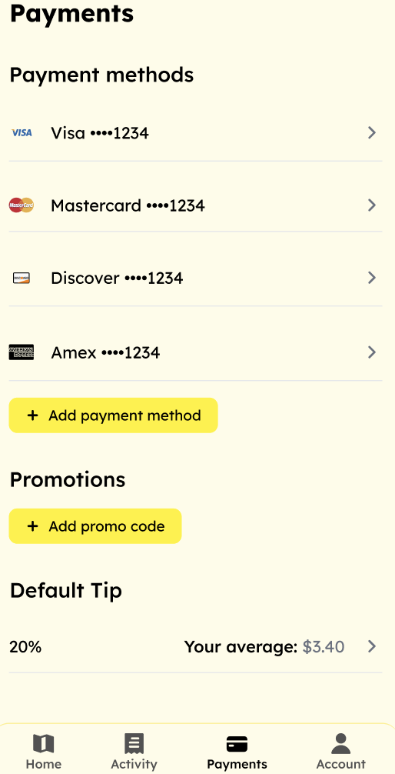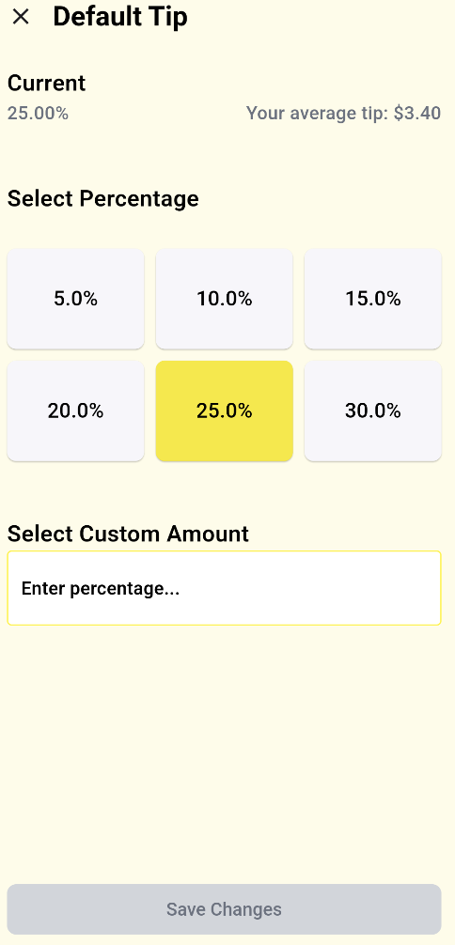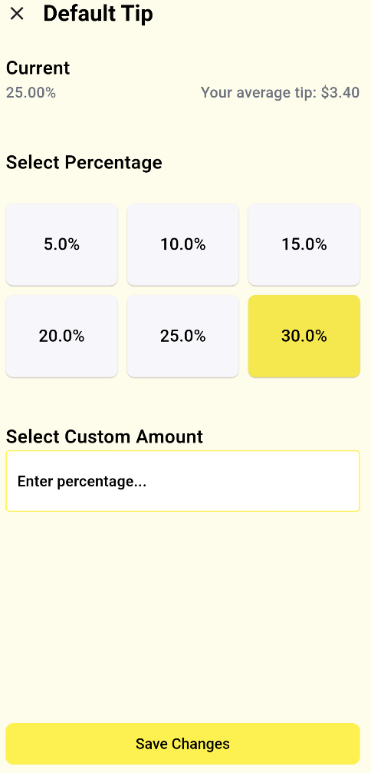

### Figure 11 - Add Tip

## 4.2 Request Ride

To request a ride, search for a destination on the home screen, and then choose a ride side from the dialogue that appears. Next choose your payment method, and wait for your driver to pick you up

.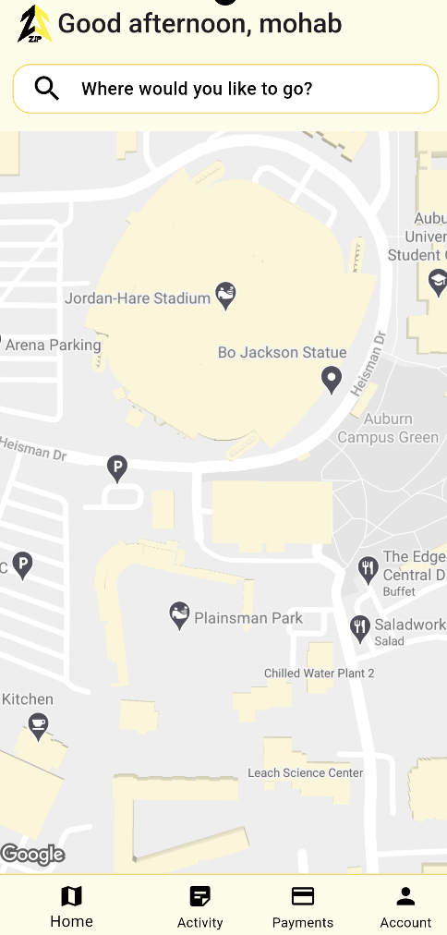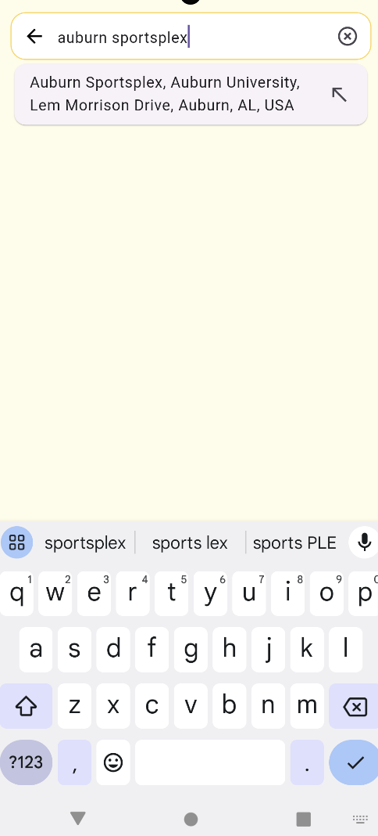

### Figure 12 - Search for destination

## 4.3 Add Payment Method

To add a payment method, navigate to the payments screen and select ‘Add Payment Method’. Then follow the instructions to add your card information.

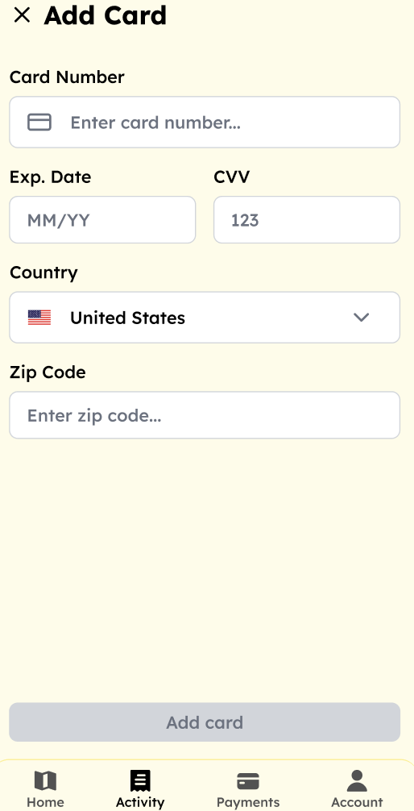

### Figure 13 - Add Payment Method

## 4.4 Delete Payment Method

To delete a payment method, navigate to the payments screen and select the method you want to delete. Then select ‘Delete Payment Method’.

## 4.5 View Previous Trips

To view your past trips, navigate to the activity screen and view your ride history.

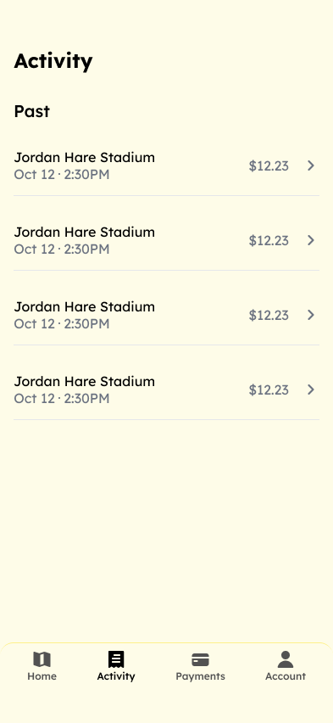

### Figure 14 - Previous Trips

## 4.6 Request Refund

To request a refund, navigate to the activity screen and select the ride that you want the refund for. Then choose the ‘Request Refund’ button.

## 4.7 Add Promo

To add a promo code to your account, navigate to the payments screen and select ‘Add promo code’. Then follow the steps to input your code.



### Figure 15 - Add Promo Code

## 4.8 Rate and Tip Driver

After completing your ride, you'll be prompted to rate and tip your driver. If you happen to forget, There's an option to revisit your previous trips and add a tip or rate your experience.

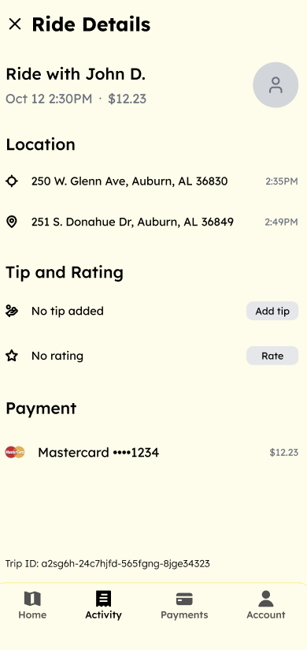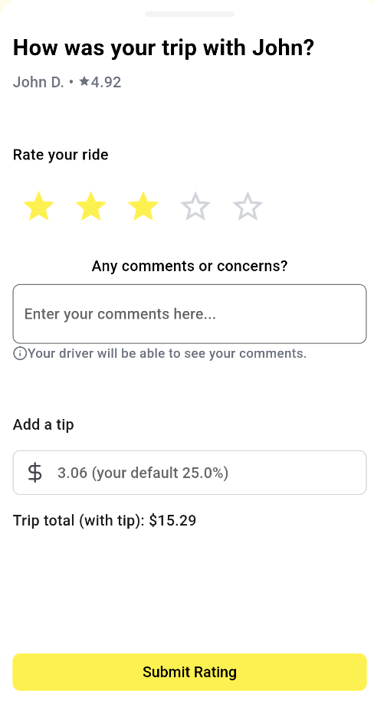

### Figure 16 - Rate & Tip Driver

# 5 Driver

## 5.1 Open Driver Portal

To access the driver portal, log in to your rider account and navigate to the account screen. Then click ‘Login as Driver’ and input your password.

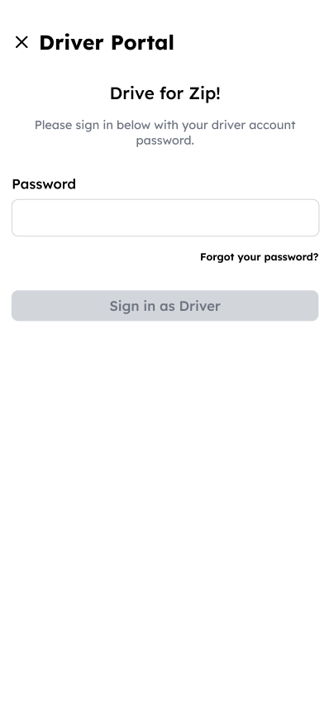

### Figure 17 - Login as a Driver

## 5.2 Start Driving

To start driving, navigate to the home screen of the driver portal and select ‘Start driving’.

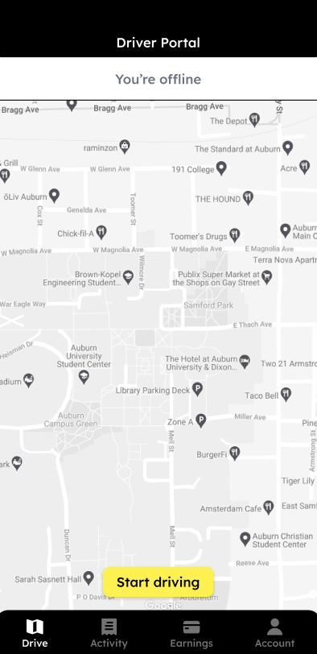

### Figure 18 - Start Driving

## 5.3 Stop Driving

To stop driving, navigate to the home screen of the driver portal and select ‘Stop driving’.

## 

### Figure 19 - Stop Driving

## 5.4 Accept a Ride

To accept a ride select ‘Accept’ on the dialogue that appears when a ride requests a ride near you.

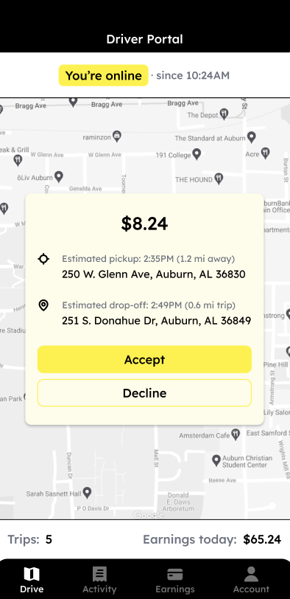

### Figure 20 - Accept a Ride

## 5.5 Finish A Ride

To finish a ride, select ‘Ride Finished’ on the persistent dialogue that appears in the app once you have accepted a ride.

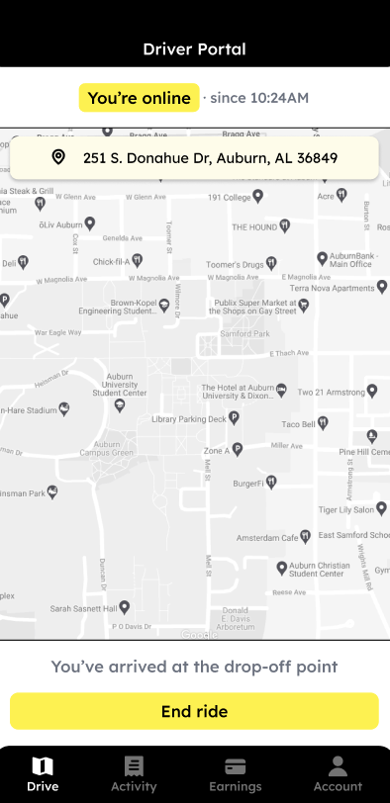

### Figure 21 - End Ride

# 6 Admin Portal

The admin portal [can be accessed here](https://zipgameday-6ef28.appspot.com).

## 6.1 Create a Promotion

To create a new promotion, please click on the 'Add Promotion' button and complete the form. Upon creation, you may view promotion details such as the number of redeemed offers, message content, and reward identification. Should the need arise, promotions can be removed by selecting the trash icon. Please note that these promotions are integrated with Firebase.

### Figure 22 - Add Promotion

## 6.2 Important Stats

In the portal, admin users may access statistical data pertaining to both rider and driver accounts, as well as promotional activities.

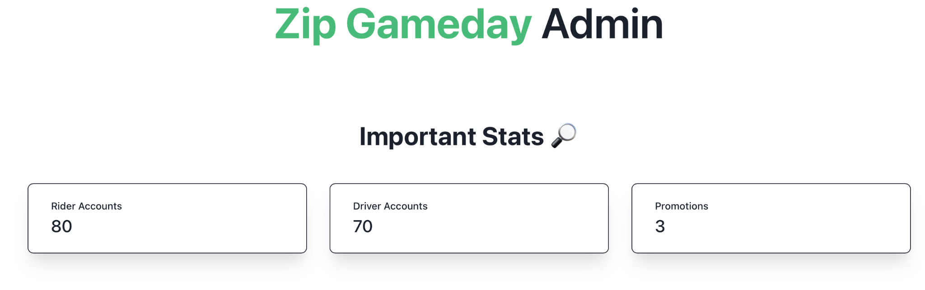

### Figure 23 - Important Stats

## 6.3 App Configuration

With various application configuration options, admin users can modify and store variables by selecting the desired settings.



### Figure 24 - App Configuration

## 6.4 User Accounts List

The inventory of user accounts and their recent activities can be accessed through the administrative portal.

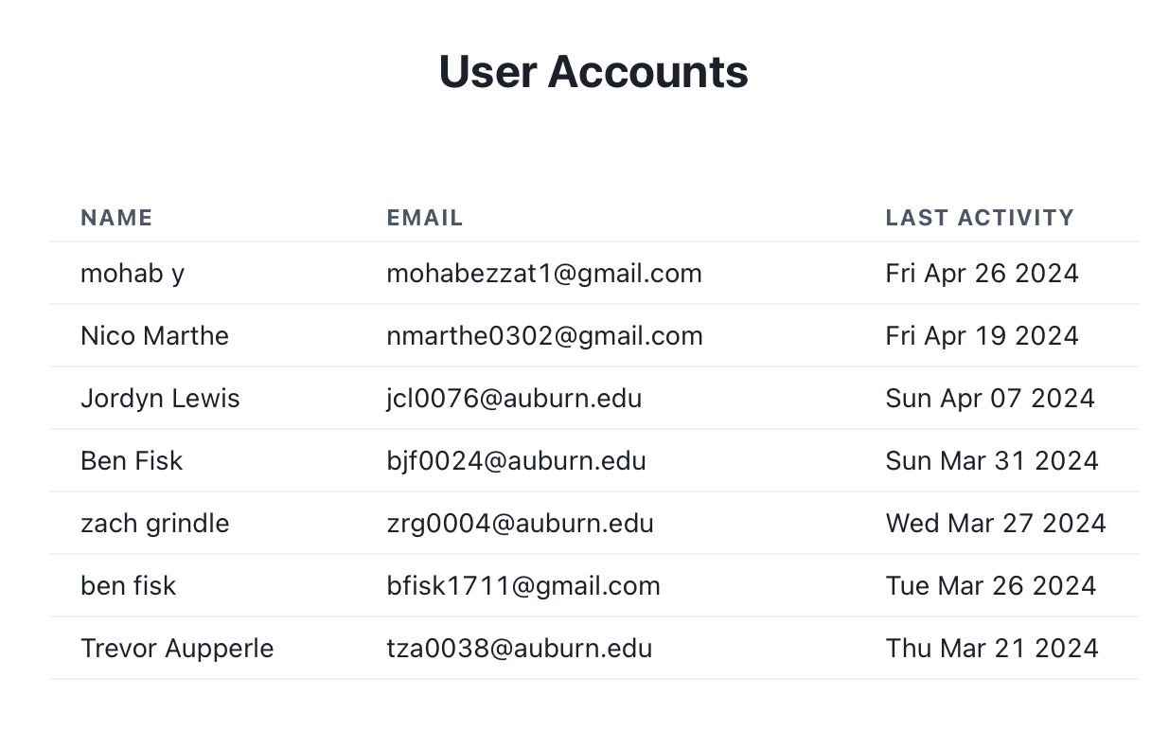

### Figure 25 - User Accounts List